National University of Computer and Emerging Sciences



**Laboratory Manuals**

*for*

**Database Systems Lab**

(CL -2005)

|  |  |  |
| --- | --- | --- |
| Course Instructor | Mr. Ishaq Raza | |
| Lab Instructor | Muhammad Umar Farooq | |
| Lab TA | Zainab Fatima | |
| Section | BDS-5A | |
| Semester | Fall 2025 |

*Department of Computer Science*

*FAST-NU, Lahore, Pakistan***Lab Manual 01**

# Objectives:

* Introduce students to the course outline and expectations.
* Familiarize students with SQL Server Management Studio (SSMS), including installation and basic configuration.
* Provide an introduction to HTML and CSS functionality.
* Practice using Visual Studio Code to set up a basic web project.

# 

# Connect to SQL Server from MSSQL Management Studio

1. Open SQL Server Management Studio
2. You will see the following pop up

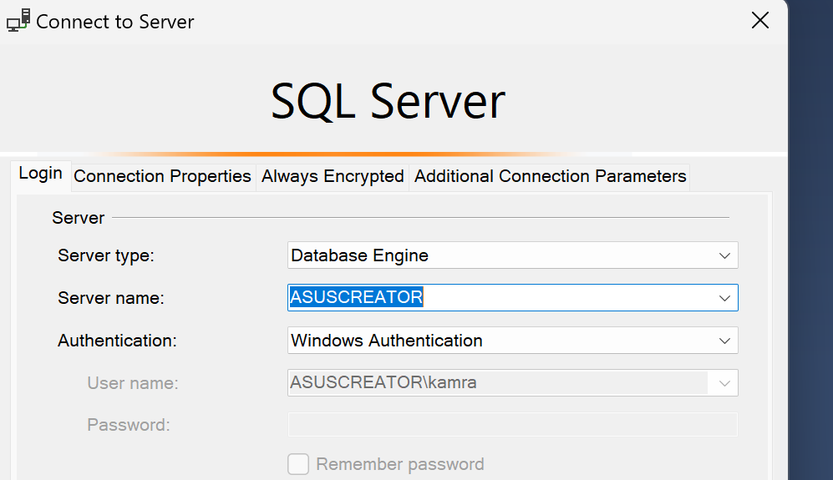

1. Enter the Server Name given by lab instructor and select SQL Server Authentication

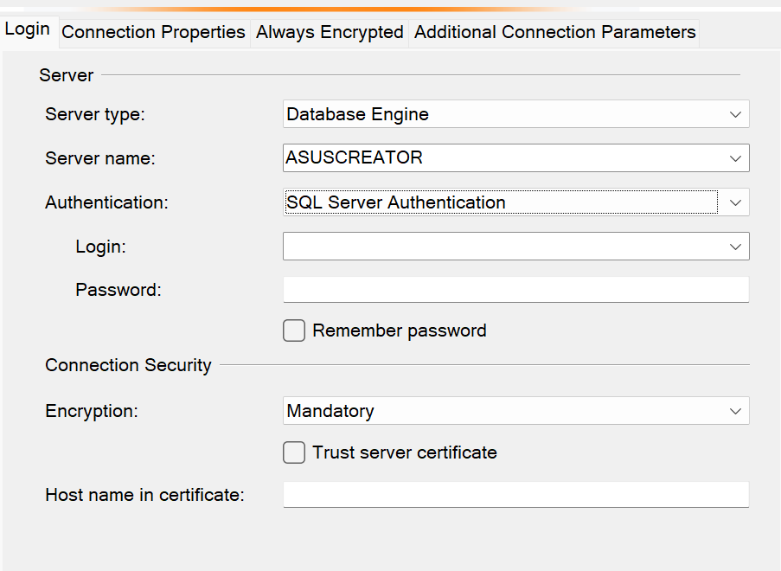

1. Click on connect after entering Username and Password. You’ll be connected to the SQL Server.
2. You’ll observe the screen similar to following

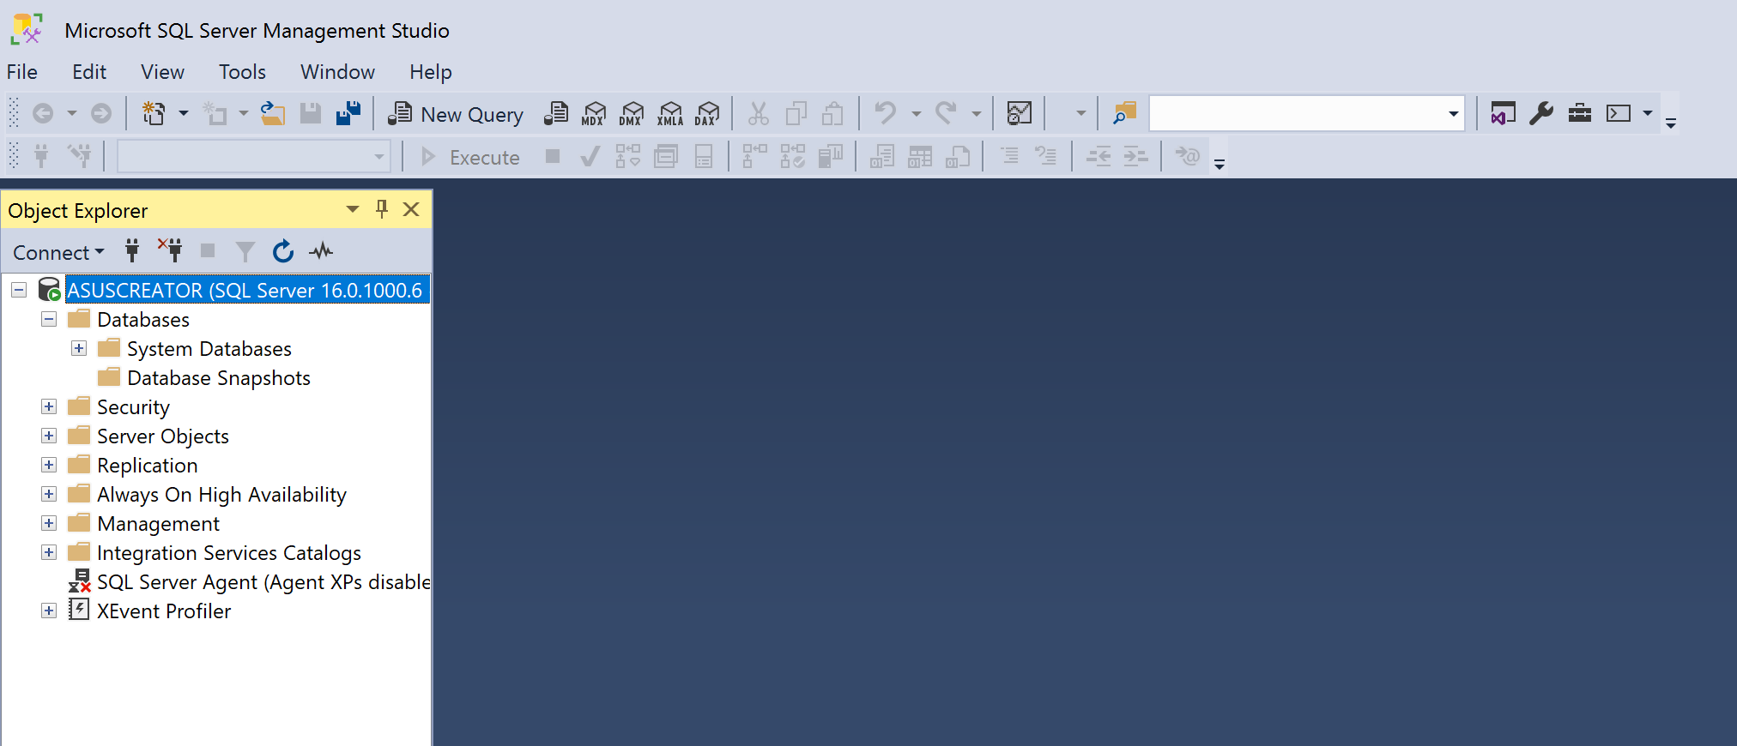

1. Click on New Query and a query file will be opened for you

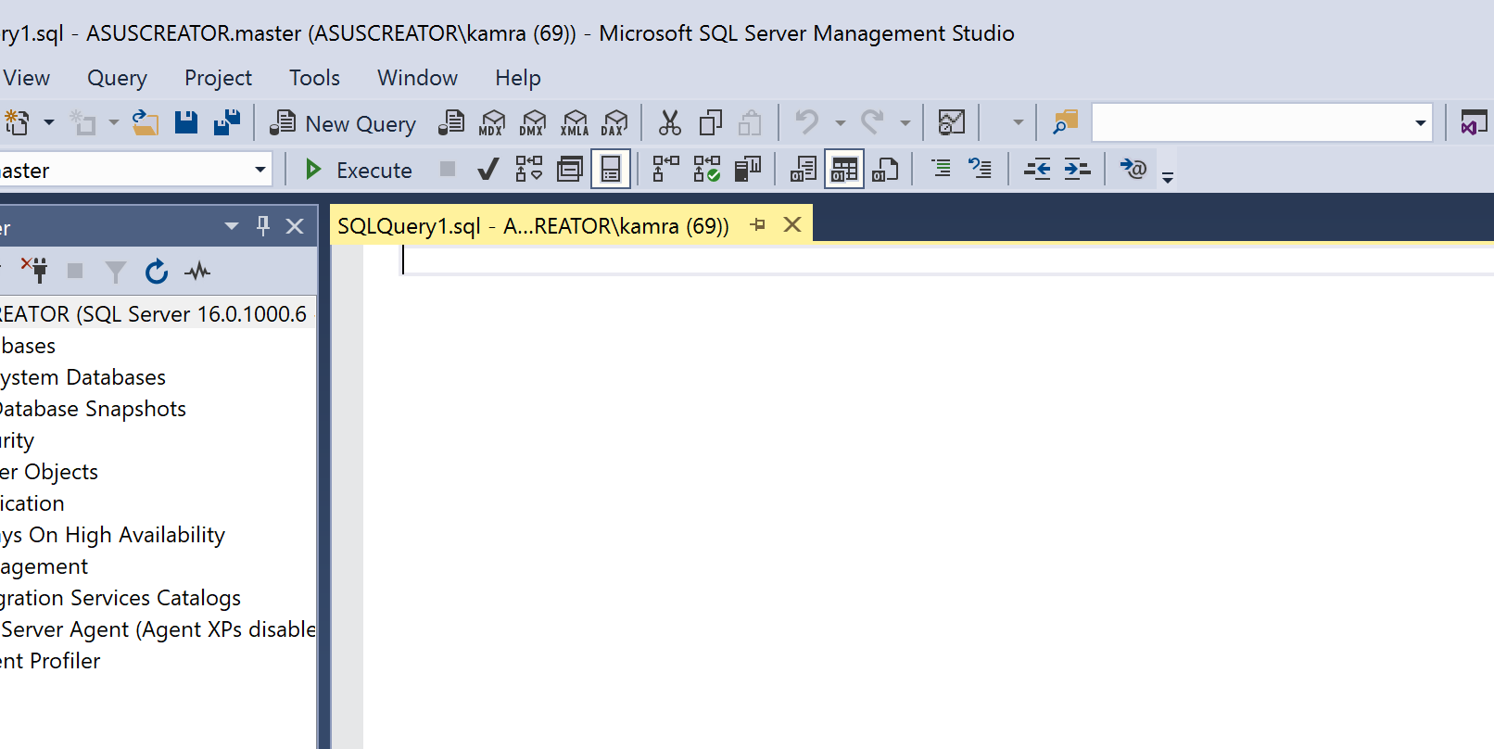

1. Write the following in the query section. This is a query to show a string “hello world” as query result

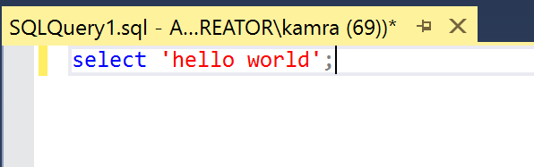

1. To execute the query click the execute button and you’ll see following

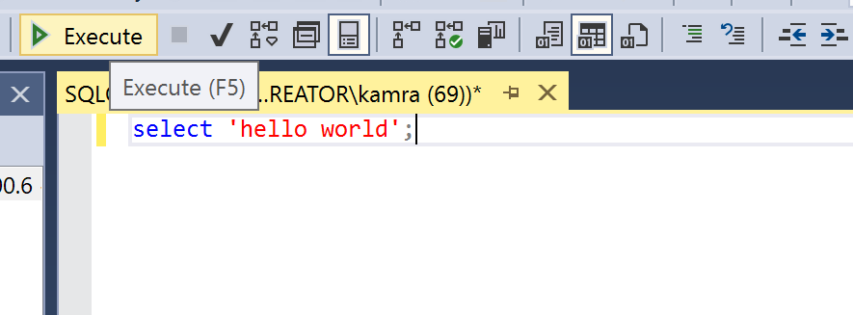

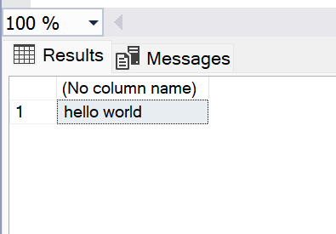

# Lab Exercise

1. Show the answer of 4+1 as query result
2. Show your roll number as string.
3. Show the date using the SELECT and GETDATE function.

SELECT GETDATE();

1. Report the result of following query

SELECT 5 + 10 AS Sum, 20 - 5 AS Difference, 4 * 5 AS Product, 20 / 4 AS Quotient;

1. Check SQL Server Version using following

SELECT @@VERSION;

## Part 2: Setting Up Node.js Backend

### Step 1: Install Node.js & VS Code

1. Download and install Node.js from the [official website](https://nodejs.org). Only if npm and node are not installed already
2. Verify the installation using following commands on cmd
   1. node -v
   2. npm -v
3. Install VS code from [here](https://code.visualstudio.com/). In lab, VS Code is already installed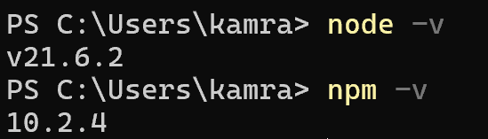

### Step 2: Initialize a Node.js Project

Create a Folder for a web project named “lab1”.

Create a new Folder for Backend in this project folder in “lab1” folder:

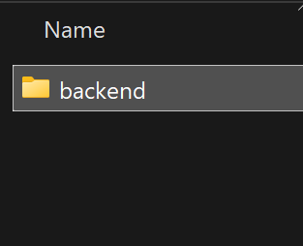

1. Open this folder with VS Code.

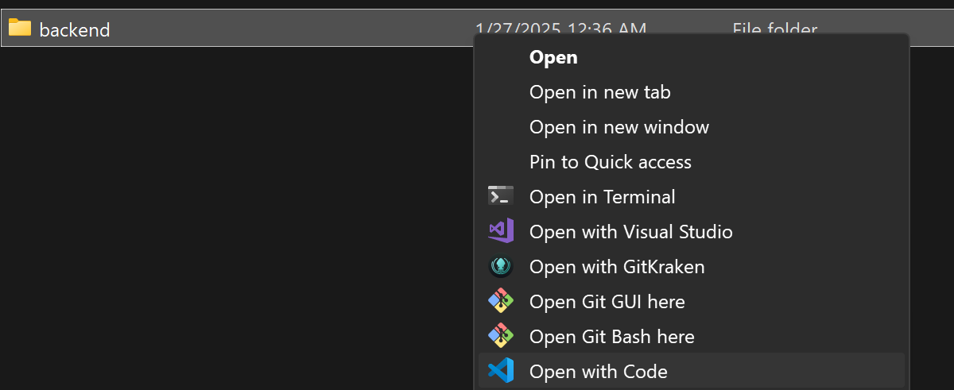

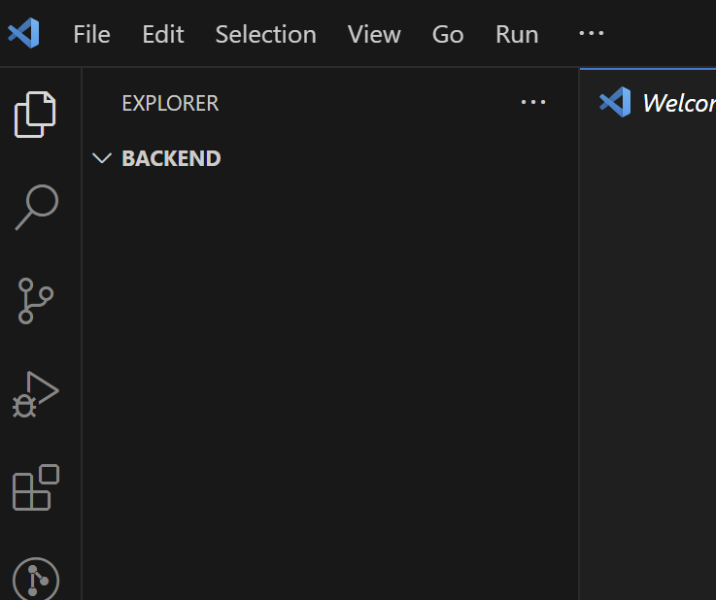

1. Open terminal in VS Code. (Hint: Use Ctrl + ~)
2. Initialize a Node.js project via terminal by command “npm init -y”  
   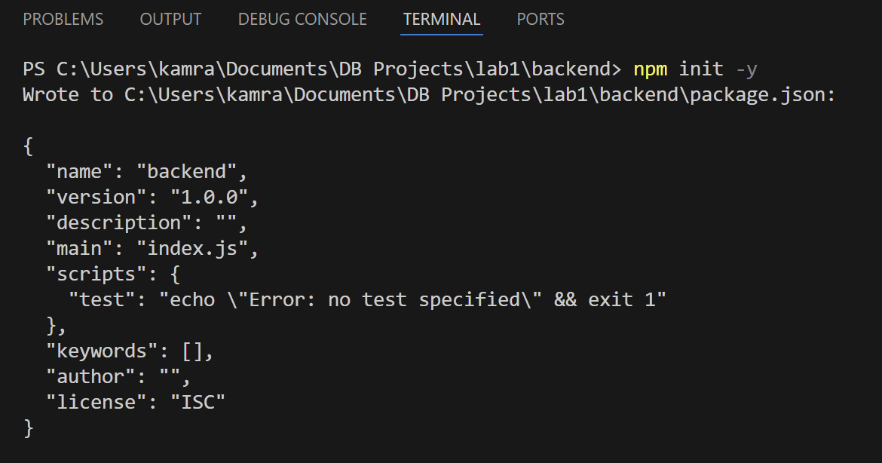
3. After this install express.js using following command  
   npm install express

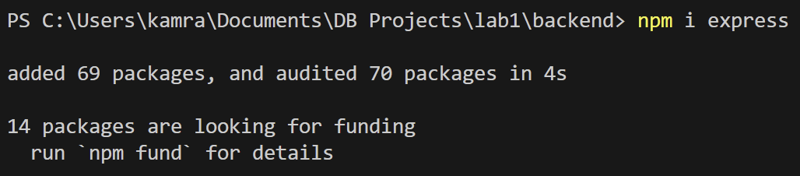

1. You will have the following folder structure

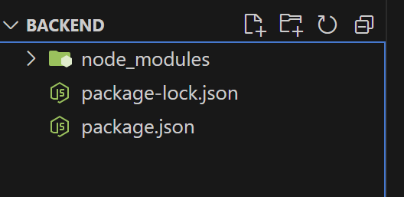

### Step 3: Create a Basic Server

1. Create a file named server.js

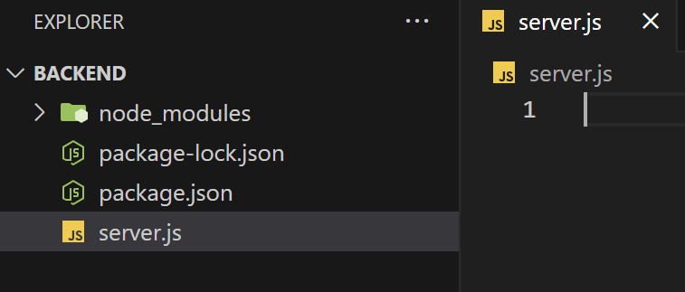

1. Add the following code to server.js:

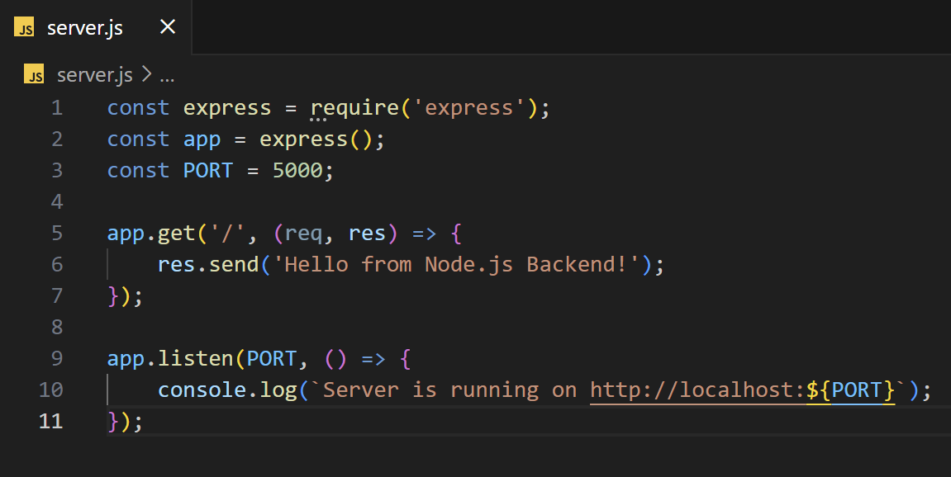

1. Run the server using following command

node server.js

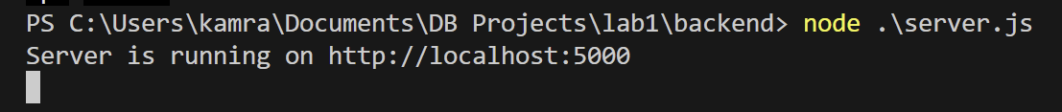

1. Open your browser and visit http://localhost:5000/ to see the response.

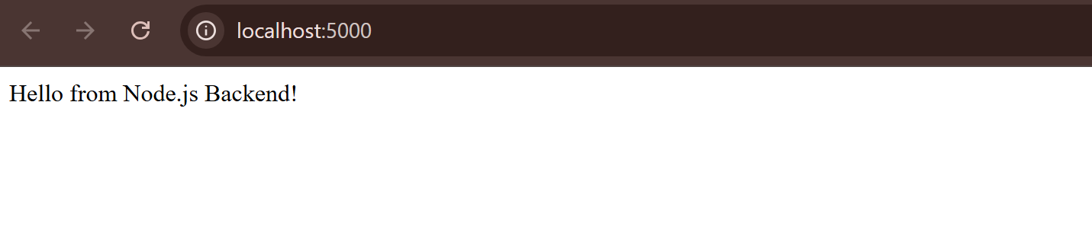

## Part 3: Setting Up React Frontend

### Step 1: Create a React App

1. Open lab1 folder using terminal/cmd/powershell.
2. In a new terminal window, create a React application using following command:  
   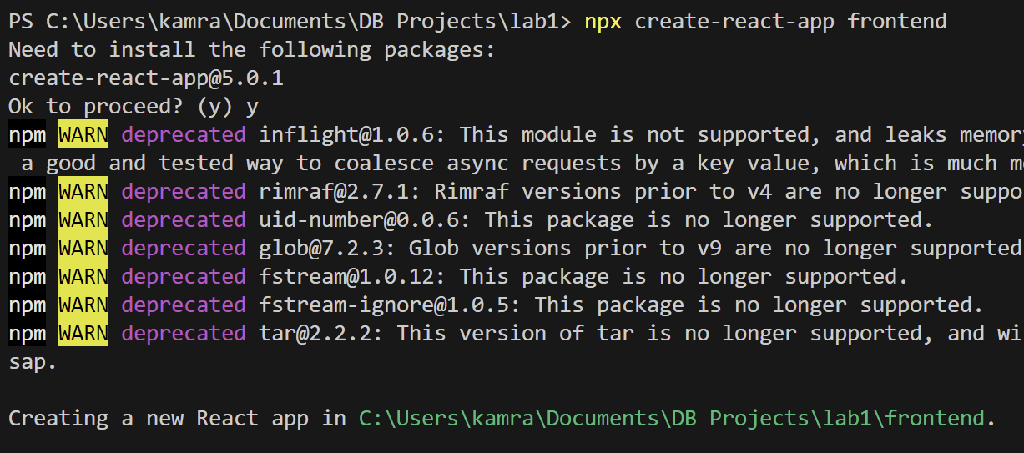

If create-react-app is not already installed, then use the following command to install it before creating frontend project

npm i create-react-app

1. Now open lab1 folder with vs code:

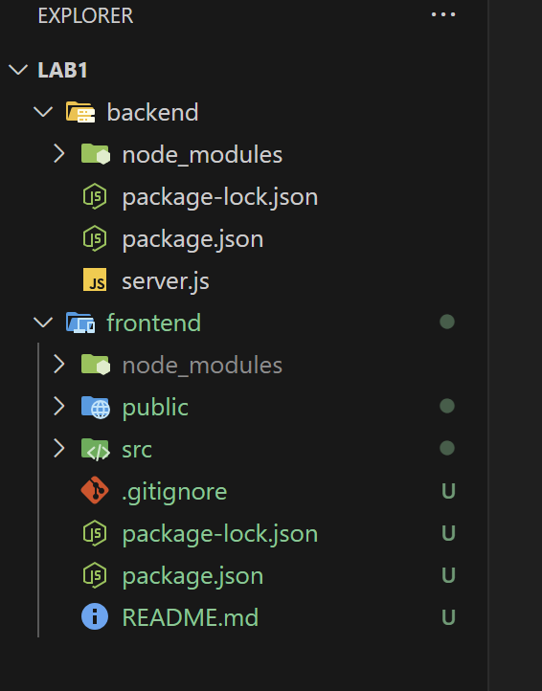

### Step 2: Modify React App

Replace the App.js file for React with following content:

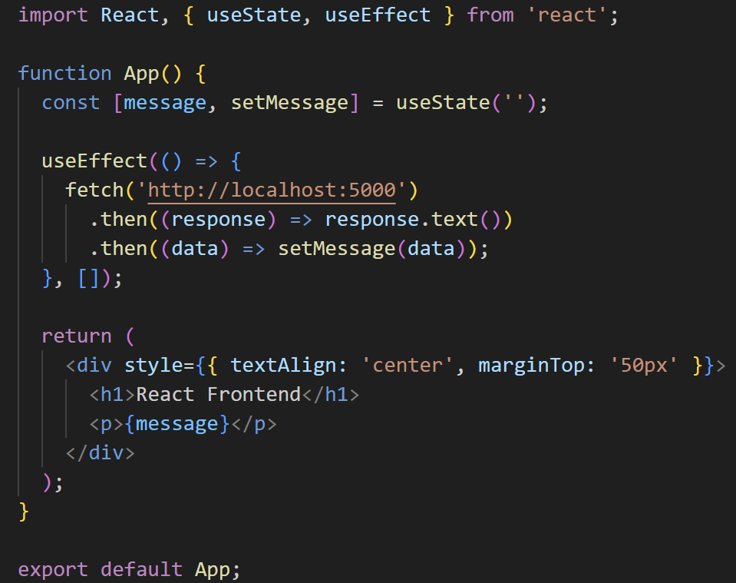

### Step 3: Start the React App

1. Open Two Terminals One for backend and one for frontend



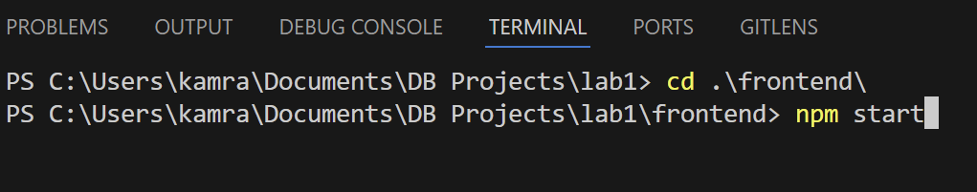

1. Open your browser and visit http://localhost:3000/
   * You will see following error in Dev Tools (Open Using Ctrl+Shift+I)

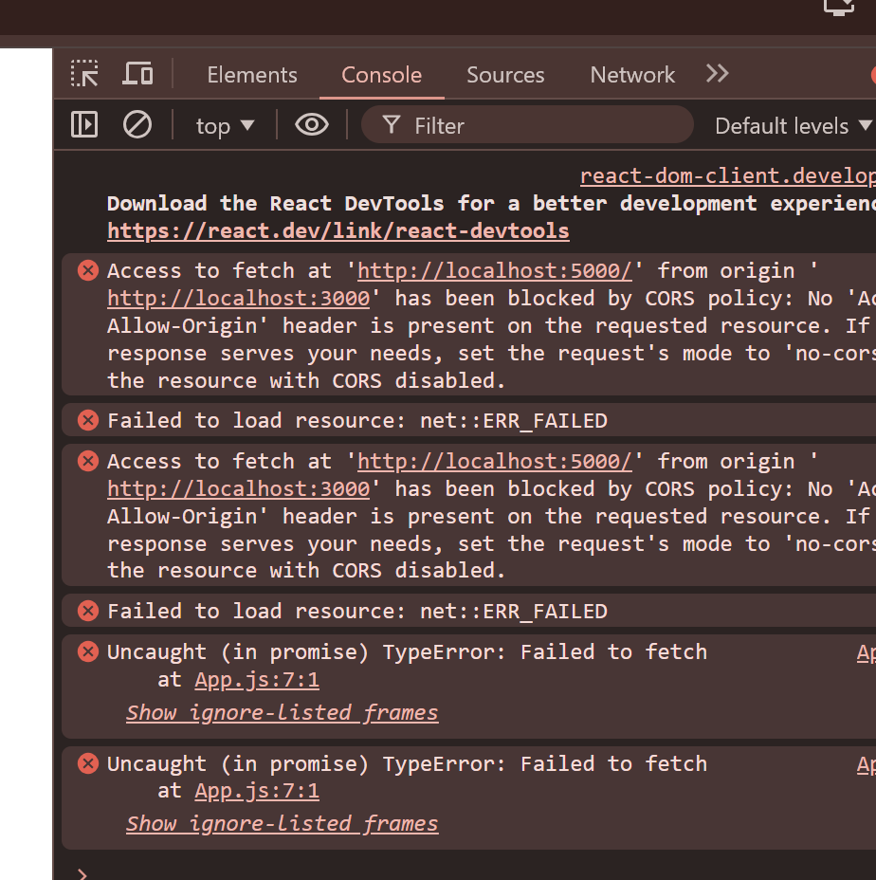

3. To resolve this, on backend tab install cors using this and run the backend server again after modifying server.js:

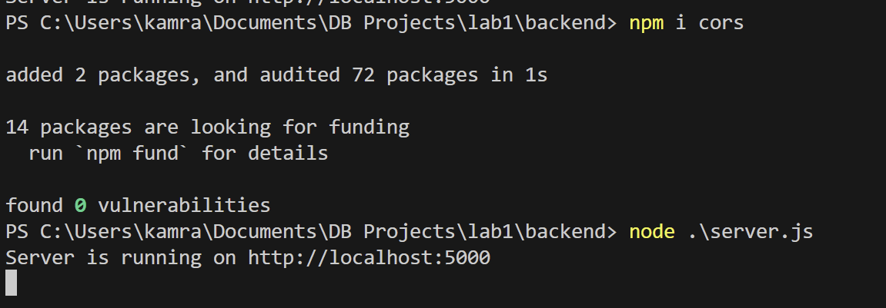

server.js:  
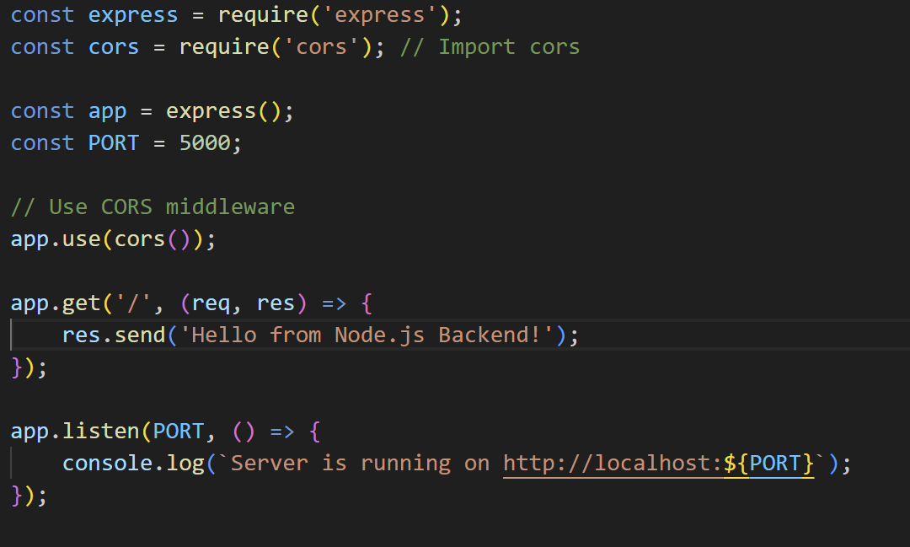

4. Refresh the frontend page at <http://localhost:3000/> and you will see

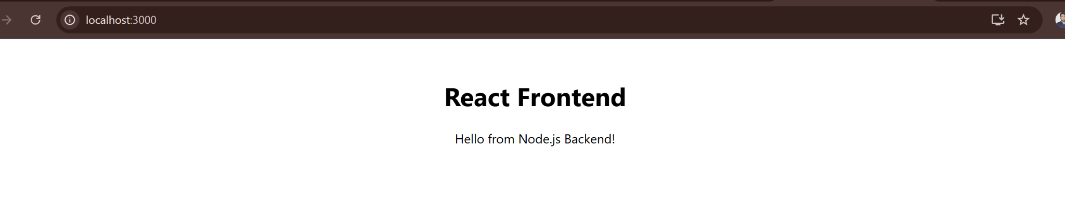

**Note: If you face any issue regarding “web vitals” not found then use this command to install them  
npm i web-vitals**

**Run frontend server again and you’ll have the error resolved**

**In Lab Exercise:**

1. **Update App.js to have html to show your picture, name, date of birth, a paragraph explaining your personality and a list of goals of your life**

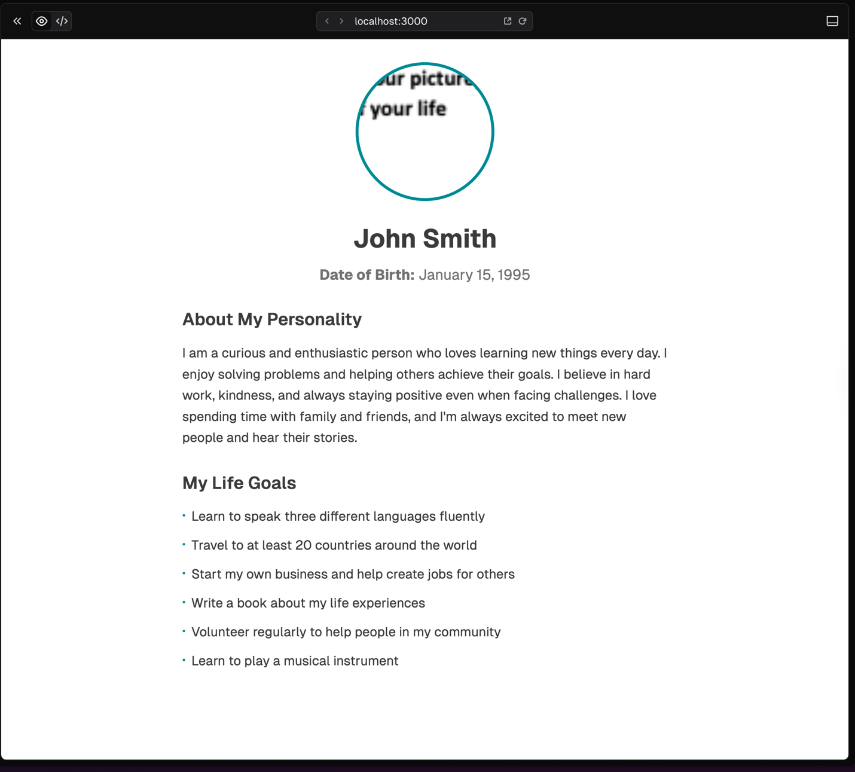

1. **Use CSS to make the information visually appealing and add one of your picture in the page**

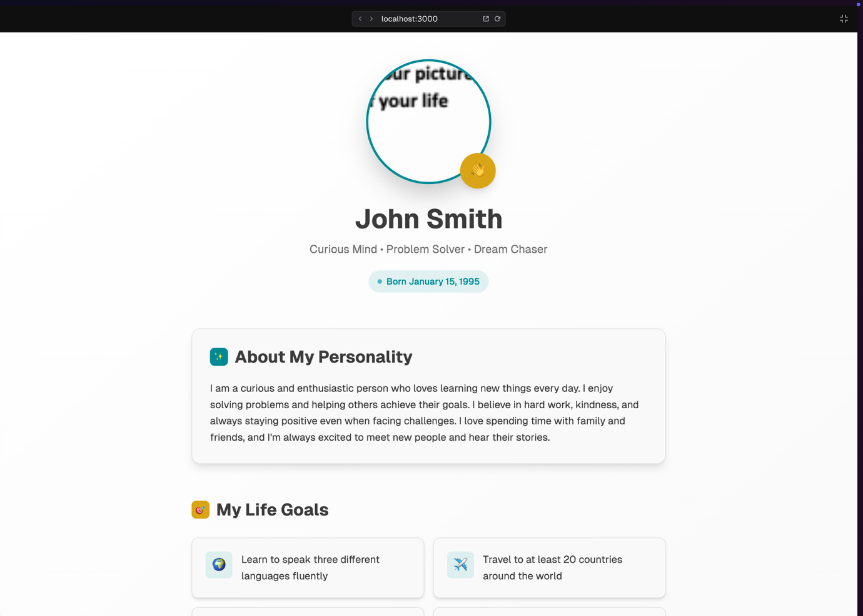

**Post Lab Exercise:**

1. **Send a list of Books from backend and show it in list format on frontend**
2. **Make the information beautiful on frontend using Html and CSS**

# Submission Guidelines

1. submit following files strictly following the naming convention
   1. l231234.sql
   2. l231234_server.js
   3. l231234_app.js
   4. l231234_app.css
   5. l231234_img.png